38.12: a) From Eq. (38.4),
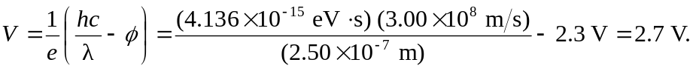
b) The stopping potential, multiplied by the electron charge, is the maximum kinetic energy, 2.7 eV.
c) 